MACHINE LEARNING LAB
MID-TERM REPORT

Mobile Price Range Classification
Name : Parthum Kumar
REG ID : 65975

Submitted To:
MANSOOR AHMED

GitHub Repository
https://github.com/parthum65975-png/Mobile-Price-Prediction

1. Introduction
This report presents the complete workflow of a Machine Learning lab practical focused on mobile phone price range classification. The objective was to build and evaluate supervised learning models that can predict the price category of a mobile phone based on its hardware specifications.
Two classification algorithms were implemented and compared:
• Logistic Regression — a linear probabilistic classifier
• Random Forest — an ensemble tree-based classifier

2. Dataset Description
A custom dataset was generated programmatically using NumPy with a fixed random seed (42) to ensure reproducibility. The dataset simulates real-world mobile phone specifications.
Dataset Overview
Property | Value
Total Records | 1,000 rows
Total Features | 8 columns (7 features + 1 target)
Missing Values | None
Target Variable | price_range (0, 1, 2, 3)
Random Seed | 42 (reproducible)
Feature Descriptions
Feature | Range | Description
battery_power | 500 – 5000 | Battery capacity (mAh)
ram | 256 – 8000 | RAM in MB — primary classifier
px_height | 0 – 2000 | Pixel resolution height
px_width | 500 – 3000 | Pixel resolution width
mobile_wt | 80 – 250 | Weight of mobile phone (grams)
talk_time | 2 – 30 | Battery talk time (hours)
camera | 2 – 64 | Camera megapixels
price_range | 0, 1, 2, 3 | Target: Low / Medium / High / Very High
Price Range Labels
Label | RAM Condition | Category
0 | RAM < 2000 MB | Low Price
1 | 2000 ≤ RAM < 4000 MB | Medium Price
2 | 4000 ≤ RAM < 6000 MB | High Price
3 | RAM ≥ 6000 MB | Very High Price

3. Exploratory Data Analysis (EDA)
Before training models, the dataset was thoroughly explored to understand its structure, distributions, and feature relationships.

3.1 Key Statistics
Average RAM: 4,014 MB
Average Battery Power: 2,815 mAh
Missing Values: None found across all columns
Correlation with Price Range: RAM = 0.968 (very strong)

3.2 Price Range Distribution
The bar chart below shows the distribution of mobile phones across the four price categories. The classes are approximately balanced, ensuring no significant class imbalance issues.
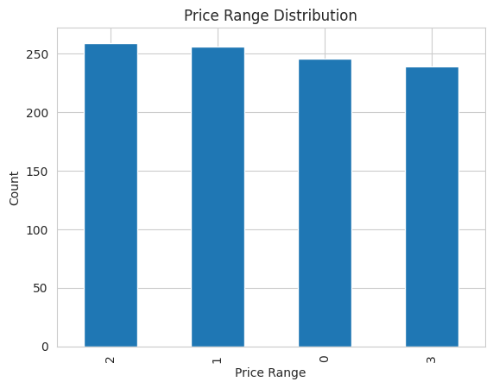
Figure 1: Price Range Distribution

3.3 RAM Distribution
RAM values are uniformly distributed between 256 MB and 8000 MB, confirming the synthetic nature of the dataset. This uniform spread is ideal for classification tasks.
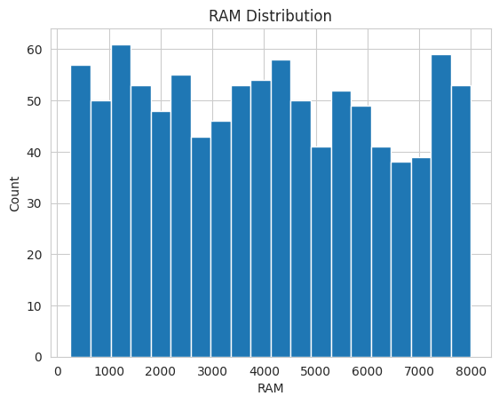
Figure 2: RAM Distribution

3.4 Battery Power Distribution
Battery power is also uniformly distributed ranging from 500 mAh to 5000 mAh. No outliers or skewness was observed.
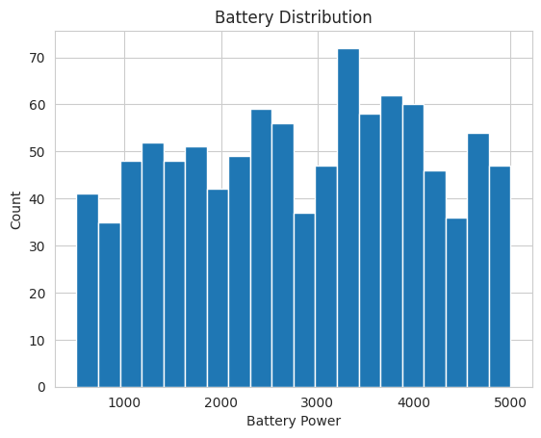
Figure 3: Battery Power Distribution

3.5 Correlation Heatmap
The heatmap reveals that RAM has an exceptionally high correlation (0.97) with the target variable price_range. Other features show very weak or negligible correlations, suggesting RAM is the dominant predictor.
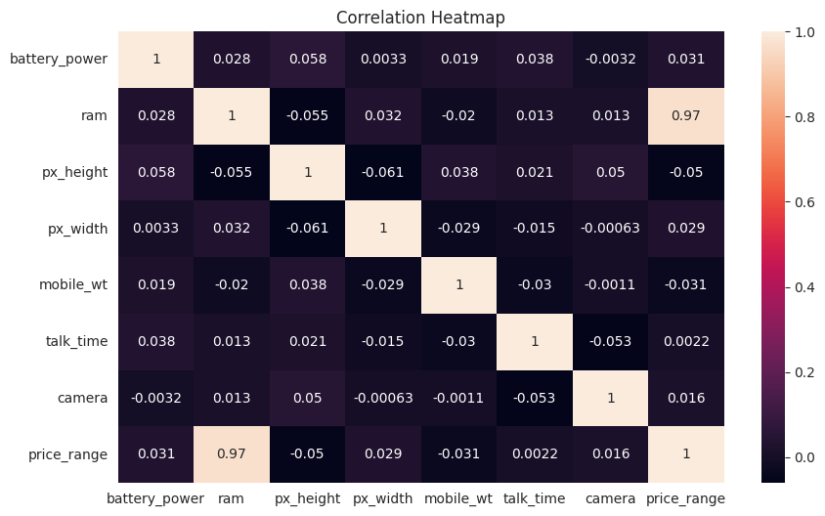
Figure 4: Correlation Heatmap of All Features

3.6 RAM vs Price Range (Scatter Plot)
The scatter plot confirms a near-perfect step-wise relationship between RAM and price_range, since the target was engineered directly from RAM thresholds during dataset creation.
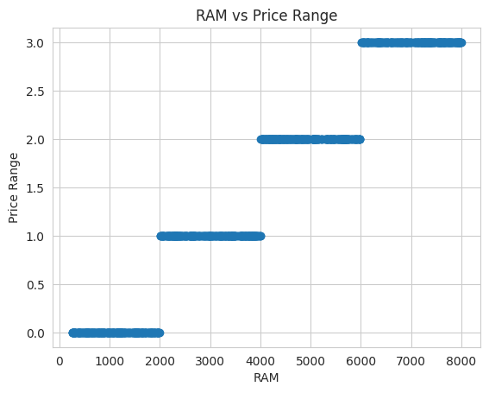
Figure 5: RAM vs Price Range Scatter Plot

4. Methodology

4.1 Data Preprocessing
Train/Test Split: 80% training (800 samples) / 20% testing (200 samples) using random_state=42
Feature Scaling: StandardScaler applied to normalize features for Logistic Regression (not required for Random Forest)
Target: price_range column (multi-class: 0, 1, 2, 3)

4.2 Models Implemented
Logistic Regression
A linear multi-class classifier from sklearn.linear_model. Configured with max_iter=1000 to ensure convergence. Standard scaling was applied as this model is sensitive to feature magnitude.
Random Forest Classifier
An ensemble method using multiple decision trees from sklearn.ensemble. Default hyperparameters were used. No feature scaling required as tree-based models are scale-invariant.

5. Results & Model Evaluation

5.1 Logistic Regression Results
Accuracy: 96.5%
Confusion Matrix:
Actual \ Predicted | Class 0 | Class 1 | Class 2 | Class 3
Class 0 | 53 | 1 | 0 | 0
Class 1 | 0 | 51 | 2 | 0
Class 2 | 0 | 1 | 47 | 1
Class 3 | 0 | 0 | 2 | 42
Classification Report:
Class | Precision | Recall | F1-Score | Support
0 | 1.00 | 0.98 | 0.99 | 54
1 | 0.96 | 0.96 | 0.96 | 53
2 | 0.92 | 0.96 | 0.94 | 49
3 | 0.98 | 0.95 | 0.97 | 44
Macro Avg | 0.97 | 0.96 | 0.97 | 200
Accuracy |  |  | 0.965 | 200

5.2 Random Forest Results
Accuracy: 99.5%
Confusion Matrix:
Actual \ Predicted | Class 0 | Class 1 | Class 2 | Class 3
Class 0 | 53 | 1 | 0 | 0
Class 1 | 0 | 53 | 0 | 0
Class 2 | 0 | 0 | 49 | 0
Class 3 | 0 | 0 | 0 | 44

5.3 Model Comparison
Model | Accuracy | Misclassified | Scaling Required
Logistic Regression | 96.5% | 7 / 200 | Yes
Random Forest | 99.5% | 1 / 200 | No
Model Comparison Chart
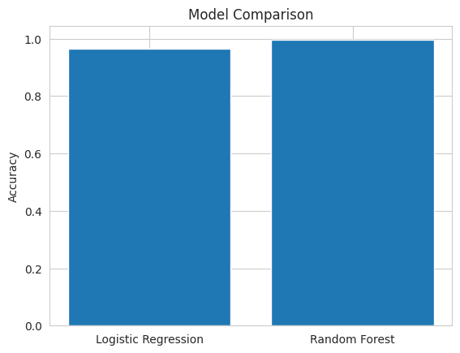
Figure 6: Accuracy Comparison — Logistic Regression vs Random Forest
Random Forest significantly outperformed Logistic Regression with 99.5% accuracy, misclassifying only 1 sample out of 200. The linear decision boundary of Logistic Regression is less suited for this problem, even though it still performed very well at 96.5%.

6. Conclusion
This project complete machine learning pipeline — from synthetic dataset generation to model evaluation — for a mobile price range classification problem.
Key takeaways from this experiment:
1. RAM is the strongest predictor of mobile price range with a correlation coefficient of 0.968.
2. Random Forest (99.5%) outperformed Logistic Regression (96.5%) due to its ensemble nature handling non-linear boundaries better.
3. Both models showed strong performance — indicating the dataset is well-structured and features are informative.
4. No missing values or class imbalance simplifies preprocessing and produces reliable results.

7. Tools & Libraries Used
Library | Purpose
Python 3 | Programming language
Pandas | Data loading and manipulation
NumPy | Dataset generation and numerical operations
Matplotlib | Data visualization (bar charts, histograms, scatter)
Seaborn | Correlation heatmap visualization
Scikit-learn | ML models, train-test split, metrics
Google Colab | Execution environment

